Eyeconic - Glasses Shop Management System

M30 - Edit Categories

Version 1.0

Revision History

|  |  |  |  |
| --- | --- | --- | --- |
| **Date** | **Version** | **Description** | **Author** |
| 05/11/2019 | 1.0 | Start creating use case | Hoàng Tiến Long |
|  |  |  |  |
|  |  |  |  |
|  |  |  |  |

Table of Contents

1. Edit Categories 4

1.1 Brief Description 4

1.2 Actor 4

2. Flow of Events 4

2.1 Basic Flow 4

2.2 Exception 4

2.2.1 Edit category 4

2.2.2 Fill in the information form 5

2.2.3 Confirming editing the category 5

3. Special Requirements 5

4. Preconditions 5

4.1 Login 5

5. Postconditions 5

6. Extension Points 5

Use-Case Specification: Edit Categories

# Edit Categories

## Brief Description

This use cacse defines the step of editing category.

Categories are edited by the admin.

## Actor

Administrator.

# Flow of Events

## Basic Flow

In categories management, the administrator selects the Category data to edit. The administrator changes the needed information. The system displays the updated management parameter value and logs the change.

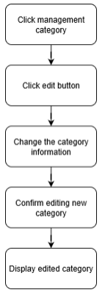

***Basic flow of editing order***

Step 1: Click management category.

Step 2: Click edit button.

Step 3: Change category information.

Step 4: Confirm editing new category.

Step 5: Display edited category.

## Exception

### Edit category

The edit button cannot be clicked or isn’t appeared on the screen

### Fill in the information form

Invalid information.

Must fill out all the information in the form.

### Confirming editing the category

The “Save” button is clicked but the category is not updated to the database due to the existed category.

# Special Requirements

No Special Requirements

# Preconditions

## Login

Actor must already login as the administrator of the website

Accuracy is required when administrator want to edit category.

# Postconditions

# Extension Points

No extension points.